Tucker Little Whitewater Rafting

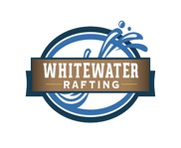

Primary Color: 396CA0

Secondary Color: B0C9E1

Accent1 Color: 71563D

Accent2 Color: F5EEE6

Heading Font: Anton

Text Font: Roboto

<https://coolors.co/fefdfb-71563d-396ca0-b0c9e1-f5eee6>